Bank Risk Controller Systems And Interactive Chatbot

PROJECT OVERVIEW
The Bank Risk Controller App is a web-based application developed using Streamlit that predicts the credit risk of loan applicants using Machine Learning models. The system helps banks to identify high-risk customers and reduce loan defaults. The application uses classification models such as:
- Logistic Regression
- Random Forest
- XG Boost

Problem Statement
Banks face significant financial loss due to loan defaults.
Traditional manual credit assessment is:
- Time-consuming
- Error-prone
- Subjective
The objective of this project is to build an automated ML-based risk prediction system that classifies applicants as:
- ✅ Low Risk
- ❌ High Risk

TECHNOLOGIES USED
Programming
- Python
Machine Learning Libraries
- Scikit-learn
- XG Boost
- Pandas
- NumPy

Visualization
- Matplotlib
- Seaborn
Web Application
- Streamlit

SYSTEM ARCHITECTURE
- Data Collection
- Data Preprocessing
- Feature Engineering
- Model Training
- Model Evaluation
- Streamlit Deployment
- Real-time Prediction

DATA PREPROCESSING
Steps performed:
- Handling missing values
- Encoding categorical variables (Label Encoding / One-Hot Encoding)
- Feature scaling (Standard Scaler)
- Removing outliers
- Train-Test Split (80:20)

MODEL EVALUATION METRICS
- Accuracy
- Precision
- Recall
- F1-Score
- Confusion Matrix
- ROC-AUC Score
Performance metrics Results:
Model | Accuracy
Logistic Regression | 58%
Random Forest | 71%
XG Boost | 96%

streamlit app deployment
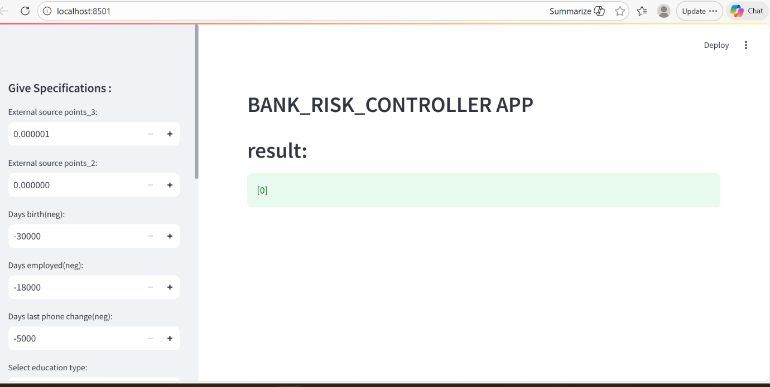

INTERACTIVE CHATBOT

interactive chatbot using langchain and Gemini
